**Smart course Management**

**System in cloud**

Project Proposal

By

**Mr. Chaichan Suttee 542115058**

**Mr. Tanadol Parn-ong 542115074**

Department of Software Engineering

College of Arts, Media and Technology

Chiang Mai University

Project Advisor

________________________

**Mrs. Yun Rim Park**

**Abstract**

In general when lecturer want to manage score they will use the program for manage score. When they want to upload the material or assignment for the student. They will send email to student .the other side is student side when they want to download they will go to the mailbox and find the mail from lecturer. In this project, we develop the web service and the mobile application with the cloud technology. User can access to our smart course management system in the cloud without the installation or handling many of the program. We collect the every feature for lecturer and student. We put it in our smart course management system in the cloud. User can use our smart course management system in the cloud by access form the mobile. Because we develop in the type of mobile application. From our smart course management system in the cloud project Student will have a convenience when they want to view the score, download material form lecturer, take assignment or quiz, upload the assignment for submit to lecturer, But not only student The convenience is for lecturer too. Lecturer can manage the score, create the true-false quiz, upload the assignment, upload the material for student. The lecturer can check who is submitted their work on time. We want to present the choice for the university or school that interested in convenience form our smart course management system in the cloud project. At last we hope our smart course management system in the cloud project can give the useful for the user who use our smart course management system in the cloud project.

Contents

Chapter One | Introduction and Background 4

Chapter Two | Literature Review 5

2.1 Business Review 5

2.2 Technology Review 9

Chapter Three Quality Standard 16

Chapter Four Project Plan 17

Chapter Five References 25

# Chapter One | Introduction and Background

In order to manage a course, instructors usually rely on many programs and websites as they calculate score, keep attendance score, receive assignment files from students, assign quizzes to students, and share course materials with students by using flash drives or uploading them to web storage. However, these mundane tasks of managing a course are not easy to carry out and often face challenges. The instructor uses work office program for calculating scores and use a website for announcing those scores that there are too many tools for managing their course. It also has too many steps for managing courses so instructors have to spend too much time for managing courses. Instructors upload materials but the students do not notice that materials were uploaded in time. Sometimes, student’s flash drive can be lost

When the instructor teaches many courses and finds these problems, it decreases the efficiency in teaching because the instructor will has less time to prepare for actual teaching. For students, they may sometimes fail to receive some information, files, or quizzes because they don’t notice them at the moment those files are uploaded. In the situation of students using flash drive for distributing files may not be done thoroughly with every student.

The problems mentioned above are not uncommon in many schools and universities. Instructors thus needs a better system to manage courses without experiencing these problems.

Smart course Management system in the cloud is a system that helps to manage score, upload/download course materials, share files and assign quizzes which provides convenience to both instructors and students. Maintaining course materials in the cloud storage, instructors can manage scores, upload materials, and create assignments, and students can download the materials, take the assignments, and view the scores.

# Chapter Two | Literature Review

## 2.1 Business Review

The general system management on cloud system is allow the user to use the application on the cloud. The user can use without the installation of the program. System allows the user to use system by login to the system. User must register to the system before use this application. After that, the user can manage their space. Some of cloud storage system provide the mobile application. The user can access to the system by using the application on the mobile.

2.1.1 Dropbox

Dropbox is a cloud-based storage system that provides data storage service. Moreover, Dropbox also provides an application that can be installed and used on smartphones. Dropbox supports major features as follows,

1. Users can upload and download files by dragging and dropping files into and out of a local folder that is synchronized periodically with the user’s storage in the cloud.
2. Users can upload and download files via web browsers.
3. Users can share files with another user of Dropbox.
4. Users can increase the size of storage by paying to Dropbox.

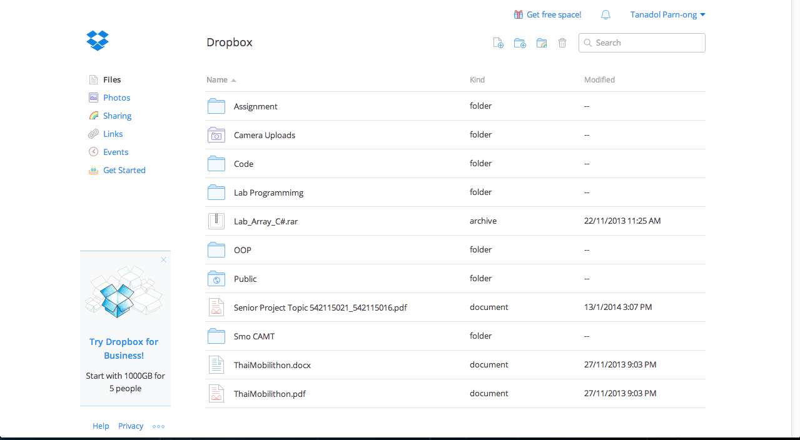

*Figure 1 Dropbox main page on the web site*

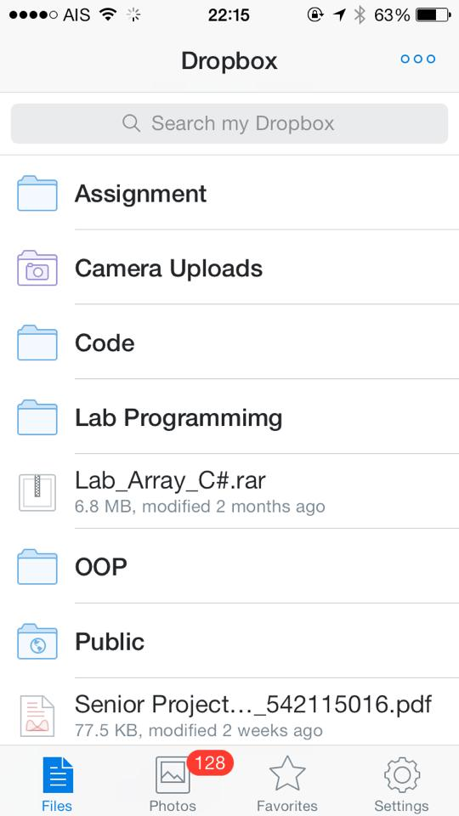

*Figure 2 Dropbox application main page on iOS*

Figure 1 shows the interface of Dropbox main page where users can click the upload files button. In the left side on Figure 1 has a sharing link which allows users to see shared files or create link to those files.

Figure 2 shows the main page of Dropbox application on iPhone where users can search file names or can select file categories.

**Similar systems**: Amazon S3, Windows Sky Drive, iDrive

Pros

Dropbox does not have to go through several steps to upload and download files. It is integrated into the workflow of common tasks. Also, resources are accessible anywhere as long as they are connected to the internet. Users can sign up and get free limited capacity of storage. Users can pay to expand storage capacity following their deman

Cons

Dropbox must add people that we need to share by filling Dropbox accounts. If has many Dropbox accounts, the user must spend time very much to fill Dropbox account. Dropbox is designed for general resource storage and sharing, but it not ideal for course management

2.1.2 CMU online

CMU online a - web service that provides data storage services to instructors and students at Chiang Mai University. CMU online supports general features as follows.

1. Instructors who are the owner of a course can upload and download files.

2. Students can join a course and download files from the course page.

3. Instructors can make announcements via the board of the website.

4. Instructors can check the number of students that joined the course.

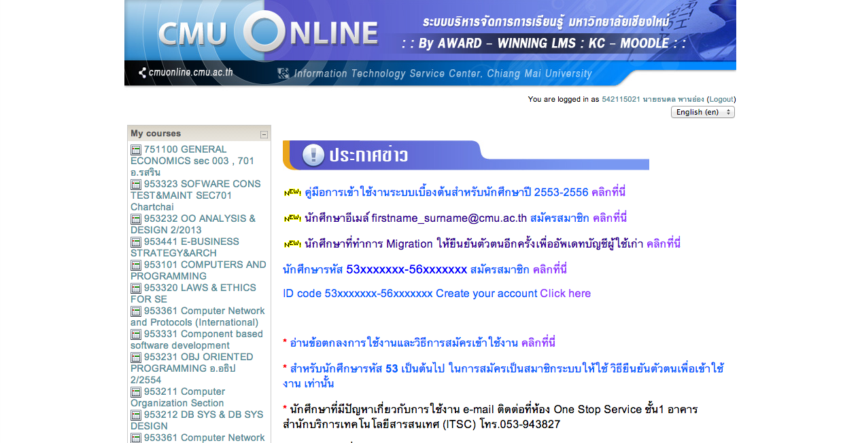

*Figure 3 CMU online main page*

Figure 3 shows the CMU online main page. When users sign in the CMU online, they can see all the courses that joined in the left side page.

Pros

CMU online a web service that is provided by Chiang Mai University. Users can sign up for free. Instructors can upload and download materials using the services provided by the system. Student can download materials from the web page. Sharing course materials is fairly easy for both instructors and students. CMU online is better than general storage web sites because an instructor can control who are allowed to join the course.

Cons

The system does not provide notifications to the users. When instructors upload files in their course page, students may not know about it unless they open and see the course page themselves.

## 2.2 Technology Review

2.2.1 Cloud computing



*Figure 4 cloud computing*

Technology description

Cloud Computing is a technology that uses internet to connect to the servers to maintain data and applications. Cloud computing allows users use applications without installation. They can access their files by the computer with internet access. Because every application is on the cloud system we can access to the application by using internet. Cloud computing allows for much more efficient computing by centralizing data storage.

The selection of this technology

1. Cloud computing is chosen because we did not want to use computer server. The computer server has many problems and limit of bandwidth and data storage. Because when the many of user join to the server system. The server can be leak and have the stack overflow. Could computing is easy to develop and design. It is the new technology for us that we interested.
2. Unlimited resources: The Cloud computing provider can provide more resource when resources are insufficient to using of users that increase.
3. Maintenance: cloud computing is easier to maintenance. The administrator can access to own server from different places.
4. Security: The Cloud computing provider are able to devote resources to security, which the many users are convinced security of own data.

2.2.2 .Net Framework



*Figure 5 Microsoft .NET*

Technology description

The Microsoft. NET Framework is a software framework developed by Microsoft to support software development targeting at Microsoft Windows. It supports several programming languages. The. NET library is available to all the programming languages, for example, C# or C + +that. NET supports. .NET is central to Microsoft’s development strategy and the development on Windows platforms.

The selection of this technology

. Net Framework is chosen because we want to create the web application service .We use the same programming constructs, such as methods, parameters, and user-defined complex types to work with Web services. The.NET Framework contains tools and infrastructure, which can be used to create Web service that can call any WWW consortium standards-compliant Web service.

2.2.4 JavaScript

Technology description

JavaScript is a programming language known as the "script," which is how it works in nature. "Translation and operations to each" command. We can add the JavaScript programming web pages to use for the calculation of both the display and receiving - transmitting. And that can interact with users immediately.

The selection of this technology

* PhoneGap used JavaScript for developing the hybrid application.

2.2.5 HTML 5

Technology description

HTML5 is a language that was developed for use as a markup language. Website for writing the latest version is being developed by WHATWG (The Web Hypertext Application Technology Working Group) has been raised by several Feature to allow developers to use more easily

The feature of html

• Semantic Markup: Adding the Element more readable and allows us to make SEO more effective.  
• Form Enhancements: Enhancements to Form such as Input type, Attribute or Element.  
• Audio / Video: support for audio and video files without the need to use the Embed Code of the Third Party.  
• Canvas: used in the drawing. It requires Java script help  
• Content Editable: Content can be edited directly through the web page.  
• Drag and Drop: Drag and Drop Object is increase performance .It increase the response between the system and the user.  
• Persistent Data Storage: There is easy to manage the data by collecting data on the user's machine.

The selection of this technology

- HTML5 can access sites easier than older version.

- HTML5 is support multimedia content.

- HTML5 is standardized for creating the user interface of website.

-Phonegap use HTML5 for create the user interface.

2.2.6 Cascading Style Sheets 3 (CSS3)



.

Figure 6 CSS3 Logo

Technology description

CSS3 is a technology for helping decorate html page. For example colour, text and layout.

The selection of this technology

- CSS3 is easier to implement page layout.

- CSS3 is a standard for html.

2.3 Development Tool Review

2.3.1 PhoneGap

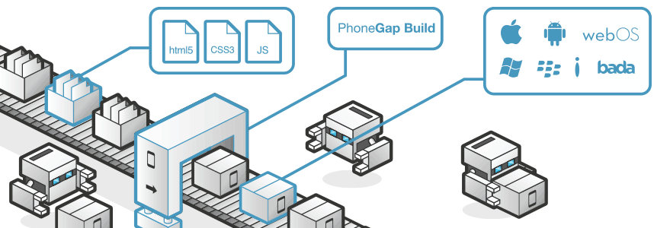

*Figure 7 phone Gap* develop tools.

Technology description

Phonegap used for developing hybrid application. Forasmuch, it is a framework for building cross-platform mobile application. Phonegap used HTML5, Javascript, CSS and converse to many platforms. For example, iOS, Android, etc. Phonegap code was contributed to the Apache Software Foundation under the name Apache and graduated to top-level project status in October 2012.

The selection of this technology

- Phonegap supports developing hybrid applications.

- Phonegap use HTML5 for developing applications, which makes it easy for developers to code.

- Phonegap can converse to many mobile platforms.

- Phonegap is a freeware.

2.2.5 visual studio

Tools description

Microsoft Visual Studio is Integrated Development Environment developed by Microsoft. A tool that enables developers, software development, computer programming, web application and web service application system that is compatible with Microsoft Windows Smartphone and a web browser. Visual Studio can be used as a .Net language. In the same program as VB.NET C + + C #.

The selection of this technology

-Visual studio is used for developing .Net Framework.

2.2.6 Xampp

Tools description

Xampp is Apache web server. It is a program to simulate a web server to test. Scripts or web sites on our machine . Without an Internet connection. Easy to install and use Xampp comes with PHP language for developing Web-based applications , MySQL database , Apache will act as a Web server , Perl also comes with OpenSSL, php My admin. Xampp is supported MySQL. Xampp database applications are in PDF format Zip, tar, 7z , or exe.

The selection of this tools

-Xampp is a freeware.

-Xampp can simulate a webserver to test.

-Xampp support multi Operating system.

2.2.7 Photoshop

Tools description

Adobe Photoshop is a program that helps create and edit images in Photoshop. It is also equipped with many tools to support the creation of videotape and multimedia presentations as well as to design and develop websites. Adobe Photoshop software package consists of two programs, Photoshop and ImageReady.

The selection of this tools

-Photoshop can create and edit images for decorating the user interface.

# Chapter Three Quality Standard

3.1 ISO 29110 for Very Small Entity(VSE)

ISO 29110 is a guide applies to a very small entity, enterprise, organization, department or project up to 25 people dedicated to software development. The guide provides project management and software implementation process which integrate practice based on the selection of ISO/IEC 12207 systems and software engineering-software life cycle process and ISO/IEC 15289 software engineering-software life cycle process guideline for the content of software life cycle process information product (documentation) standards elements

3.1.1 Project management process

The purpose of the software management process is to establish and carry out in a systematic way the task of the software implementation project which allows complying with the project’s objectives in the expected quality. Time and cost

Selected process

3.1.1.1 Project planning process

3.1.1.2 Project plan execution process

3.1.1.3 Project assessment and control process

3.1.1.4 Project closer process

3.1.2 Software implementation process

The purpose of the software implementation process is the systematic performance of the analysis, design, construction, integration and test actives for new or modified software products according to the specified requirements.

Selected process

3.1.2.1 Software implementation process

3.1.2.2 Software requirement analysis process

3.1.2.3 Software architectural design process

3.1.2.4 Software construction process

3.1.2.5 Software integration process and test process

3.1.2.6 Software delivery process

# Chapter Four Project Plan

## 4.1 Motivation

From the several problem of study in the Course, ex. student cannot come for study or take an assignment, but almost Thai students have the smartphone and computer. This is the reason why they must use this software to get the convenience from our device. Nowadays most students in Thailand use smartphones and the use of mobile devices is growing very fast, so it is the purpose to using this advantage to develop the project. Smart Course system is the project that we interesting. Sometime student must install the program for use the system

So that is the reason to create and develop it with cloud storage. Smart Course System design to uses it with iOS application to access to the cloud for upload/download and take the Assignment. So this inspired us to develop the mobile application for helping the student to get more choice. This inspired us to develop the mobile application for helping the student to get convenience. This project provides the cloud storage system and iOS mobile application that helps about the managing course for users. This will make users convenience.

## 4.2 Aims and object

4.2.1 Aims The aims of this project are to 4 parts.

* The first part is to develop web services which support score management, resource sharing, assignment and quiz management, and communication service for lecturers.
* The second part is to develop web services which help view scores, share resources, take assignments and quizzes, and communicate with lecturers for students.
* The third part is to develop a mobile application which supports score management, resource sharing, and communication for lecturers.
* The four part is to develop a mobile application which help view score system, share resources, take assignments and quizzes, and communicate with lecturers for students.

4.2.2 Objective

* To build a system which helps

lecturers share study materials and communicate with students more easily.lecturers manage courses more efficiently by saving time and effort wasted in using many different tools.students access study materials more easily and conveniently.

To develop a mobile application run on iOS devices that provides more convenience to the users by making the web services accessible via smartphones

## 4.3 Deliverables and limits

4.3.1 Deliverables

WebApplication



Student

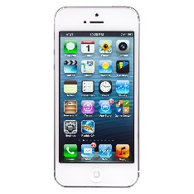



Teacher

figure 8 the architecture of Smart course Management system in the cloud

The architecture of Smart course Management system in the cloud is shown in figure 4. It consists of two parts. The first part is the web application used by instructors to manage the courses they own. They can upload teaching materials, download files submitted by students, create quizzes (i.e. true / false, multiple choice, or short answer quizzes), and share files to specific students. Instructors can manage resources on their computer which is connected to the internet. The second part is the student side. They can get assignments, download course materials, check their scores, or receive notifications by using the application installed on iOS-based mobile devices or web browsers on their computer.

4.3.2 Deliverables

-Proposal

-Project plan

-Software requirement specification

-Software design document

-Testing document

-Traceability record

-Software quality assurance document

-Certification client and server system

-Video clips for demo program

-Poster A1 for presentation

4.3.3 Limits

- The mobile application supports smartphones that run on the iOS version 7.0 or later.

- Internet connection is required for using this system.

- Users can use the services with theserver configured by this system only.

- Users need to log in before using the system.

- The alert service is not provided when users are not logged into the system or the user’s mobile application is in offline mode.

## 4.4 Future Work

The license can be implemented for education. This system can be used in any universities and schools that would like to use the system to support instructors or teachers in course/class management.

The universities would have the benefit from our system .Students and instructors would have more convenience from our system. The system can be further expanded to support some courses or classes that need additional features. The system may also support other types of devices and platforms such as …………………

## 4.5 Schedule & Milestones



**Proposal Milestone**



**Progress report I**



**Progress report II**



**Progress report III**



**Final Progress**

4.5.1 Features

**Feature#1 Score Management**

Use Case 1-1 User can view scores

Use Case 1-2 User can manage scores.

Use Case 1-3 User can view assignment scores.

Use Case 1-4 User can manage assignment scores.

Use Case 1-5 User can manage the score from a file upload of student.

Use Case 1-6 User can calculate grade using a score table.

Use Case 1-7 User can report scores.

Use Case 1-8 User can report grades.

Use Case 1-9 User can see scores.

Use Case 1-10 User can notify another user when he/she announces scores

Use Case 1-11 User can receive the notification from Instructor.

**Feature#2 Assignment and quiz management**

Use Case 2-1 Student can take a true or false quiz.

Use Case 2-2 User can take a multiple choices quiz.

Use Case 2-3 User can take a short answer quiz.

Use Case 2-4 User can create a true or false quiz.

Use Case 2-5 User can create a multiple choices quiz.

Use Case 2-6 User can create a short answer quiz.

Use Case 2-7 User can notify to Student when he/she creates a quiz.

Use Case 2-8 User can receive the notification from Instructor.

Use Case 2-9 User can see who’s join to a quiz.

Use Case 2-10 User can limit access to the shared resources.

**Feature#3 Resource Sharing**

Use Case 3-1 User can download files.

Use Case 3-2 User can upload files.

Use Case 3-3 User can limit access to the shared resources.

Use Case 3-4 User can notify Student when he/she shares a new resource.

Use Case 3-5 User can receive the notification from Instructor.

Use Case 3-6 User can read .pdf files.

Use Case 3-7 User can share resources with Student.

Use Case 3-8 User can see who’s join to the resource sharing files.

** manage (add/edit/delete)

**Feature#4 Communication service**

Use Case 4-1 User can comment on Student’s file upload.

Use Case 4-2 User can comment in report score page in the web site.

Use Case 4-3 User can comment in report grade page in the web site.

**Relation Use Case & Users**

|  |  |  |  |  |
| --- | --- | --- | --- | --- |
| Use Case number | Instructor | | Student | |
| Web service | iOS | Web site | iOS |
| Use Case 1-1 | ✔ | ✔ | ✔ | ✔ |
| Use Case 1-2 | ✔ |  |  |  |
| Use Case 1-3 | ✔ |  |  |  |
| Use Case 1-4 | ✔ |  |  |  |
| Use Case 1-5 | ✔ |  |  |  |
| Use Case 1-6 | ✔ |  |  |  |
| Use Case 1-7 | ✔ |  |  |  |
| Use Case 1-8 | ✔ |  |  |  |
| Use Case 1-9 |  |  | ✔ | ✔ |
| Use Case 1-10 | ✔ | ✔ |  |  |
| Use Case 1-11 |  |  | ✔ | ✔ |
| Use Case 2-1 |  |  | ✔ | ✔ |
| Use Case 2-2 |  |  | ✔ | ✔ |
| Use Case 2-3 |  |  | ✔ | ✔ |
| Use Case 2-4 | ✔ |  |  |  |
| Use Case 2-5 | ✔ |  |  |  |
| Use Case 2-6 | ✔ |  |  |  |
| Use Case 2-7 | ✔ |  |  |  |
| Use Case 2-8 |  |  | ✔ | ✔ |
| Use Case 2-9 | ✔ |  |  |  |
| Use Case 2-10 | ✔ |  |  |  |
| Use Case 3-1 | ✔ | ✔ | ✔ | ✔ |
| Use Case 3-2 | ✔ | ✔ | ✔ | ✔ |
| Use Case 3-3 | ✔ | ✔ |  |  |
| Use Case 3-4 | ✔ | ✔ |  |  |
| Use Case 3-5 |  |  | ✔ | ✔ |
| Use Case 3-6 | ✔ | ✔ | ✔ | ✔ |
| Use Case 3-7 | ✔ | ✔ |  |  |
| Use Case 3-8 | ✔ | ✔ |  |  |
| Use Case 4-1 | ✔ | ✔ | ✔ | ✔ |
| Use Case 4-2 | ✔ | ✔ | ✔ | ✔ |
| Use Case 4-3 | ✔ | ✔ | ✔ | ✔ |

# Chapter Five References

[1] ISO 29110

DATE 24/1/2014

<http://en.wikipedia.org/wiki/ISO_29110>

[2] Cloud computing

DATE 24/1/2014

<http://www.infoworld.com/d/cloud-computing/what-cloud-computing-really-means-031>

[3].Net framework

DATE 29/1/2014

<http://msdn.microsoft.com/en-us/library/ms644566(v=vs.85).aspx>

[4] Phone Gap

DATE 2/2/2014

http://phonegap.com/about/

[5] Cloud computing

DATE 16/2/2014

<http://en.wikipedia.org/wiki/Cloud_comuting>

[6] HTML5

DATE 2/2/2014

<http://www.microsoft.com/thailand/msdn/ie9_html5.aspx>

[7] VISUAL STUDIO

DATE 2/2/2014

<http://www.visualstudio.com/th-th/explore/application-development-vs>

[8] XAMPP

DATE 2/2/2014

<http://www.mindphp.com/%E0%B8%84%E0%B8%B9%E0%B9%88%E0%B8%A1%E0%B8%B7%E0%B8%AD/73-%E0%B8%84%E0%B8%B7%E0%B8%AD%E0%B8%AD%E0%B8%B0%E0%B9%84%E0%B8%A3/2637-xampp-%E0%B8%84%E0%B8%B7%E0%B8%AD%E0%B8%AD%E0%B8%B0%E0%B9%84%E0%B8%A3.html>

[9] JAVA SCRIPT

DATE 2/2/2014

<http://en.wikipedia.org/wiki/JavaScript>

[10] PHOTOSHOP

DATE 2/2/2014

http://en.wikipedia.org/wiki/Adobe_Photoshop

Image

[1]*Figure 1 Dropbox main page*

DATE 24/1/2014

<http://www.dropbox.com>

[2]*Figure 2 Dropbox main page*

DATE 24/1/2014

Dropbox in mobile phone

[3] *Figure 3 CMU online main page*

DATE 24/1/2014

<http://cmuonline.cmu.ac.th/>

[4] *Figure 4 cloud computing*

https://www.data-hive.com/academy/primer.php

[5] *Figure 5 Microsoft .NET*

DATE 19/2/2014

[6] *Figure 6* CSS Logo

http://blogs.microsoft.co.il/gilf/2011/12/14/css3-animations/

[7] *Figure 7 phone Gap* develop tools

DATE 2/2/2014

<http://phonegap.com/about/>